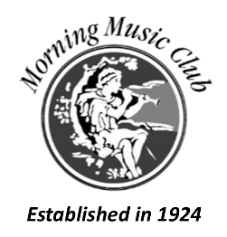

RECOMMENDED GUIDELINES FOR AUDITION

Please do not return this page with the application form so you may refer to the guidelines required for the audition. Auditions will be 15 minutes long and judges may interrupt a piece to give the candidate time to perform a second selection to meet the guidelines set below.

VOCAL

Audition pieces must be sung in at least 2 different languages and at least 2 contrasting genres, or contrasting movements.

BRASS, WOODWINDS and STRINGS

Audition pieces must include at least 2 contrasting genres, or contrasting movements.

KEYBOARD

Audition pieces must include 2 contrasting pieces by genres, or contrasting movements.



